**LAB # 01**

**Task # 01: Take user information as an input from user and print his bio using python.**

**Solution:**

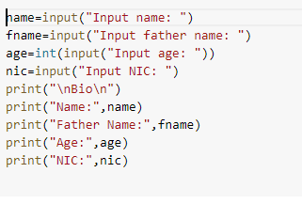

**Output:**

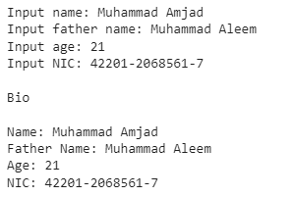

**Task # 02: Write Pythonic code to solve the quadratic equation ax**2 + bx + c = 0 by getting input for coefficients from the user.**

**Solution:**

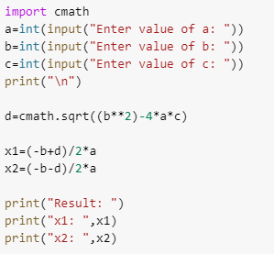

**Output:**

